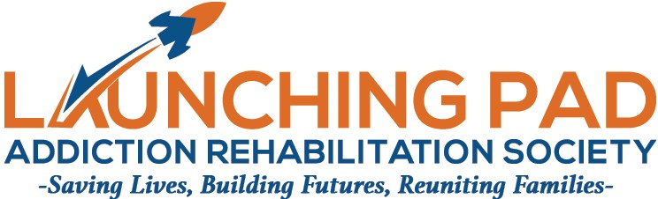

2022 MEMBERSHIP INVITATIONAL FORM
ALL APPLICANTS WILL BE ADVISED BY EMAIL OF THEIR STATUS
MEMBERS WILL BE EXPECTED TO ADVOCATE AND PARTICIPATE IN THE OPERATION OF THE LAUNCHING PAD
MEMBERSHIP IS CAPPED AT 50 FOR 2022

Name:

Company (if Applicable):

Street Address:

City: Province:

Country: Canada Postal Code:

Phone: Email:

Applicants Signature:

Being Invitational there is no fee for membership. Membership starts with acceptance by the Society and requires renewal annually prior to the Annual General Meeting so that all members can participate in the AGM. This year’s AGM will be held on Wednesday May 25, 2022 from 6:30PM – 8:30PM Via ZOOM. Meeting details will be forwarded to members 7 days prior to the meeting.

Please return you application to ken.falconer@launching-pad.org before 5.00PM May 15, 2022 so that your membership can be considered and voted on by the board at it’s regular monthly meeting.

If you have a desire to apply for a position on the board, please indicate below so that you can be brought forward at the AGM.

I wish to be considered for a position on the Board of the Launching Pad. YES

If you know of anyone who you feel would be a good fit as a member of the Society, please forward this document to him or her. Please note that current and former employees and guests of the Launching Pad are ineligible for membership. These individuals have the opportunity to be a part of our peer programming and we recognize the valuable input of these individuals.

Thank you for you support of the Launching Pad and I hope to see you, via Zoom on Wednesday May 25.

Ken Falconer Board President

